SVN ->Git -> Stash
- We need to do the following steps in Git Bash
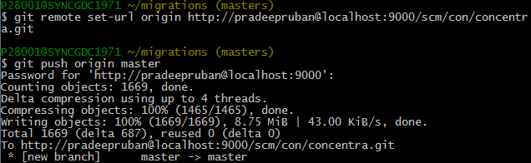

- Once we did we can go ahead and check in stash corresponding repository.
// This is my local (Syntel ) machine trial stash repository.
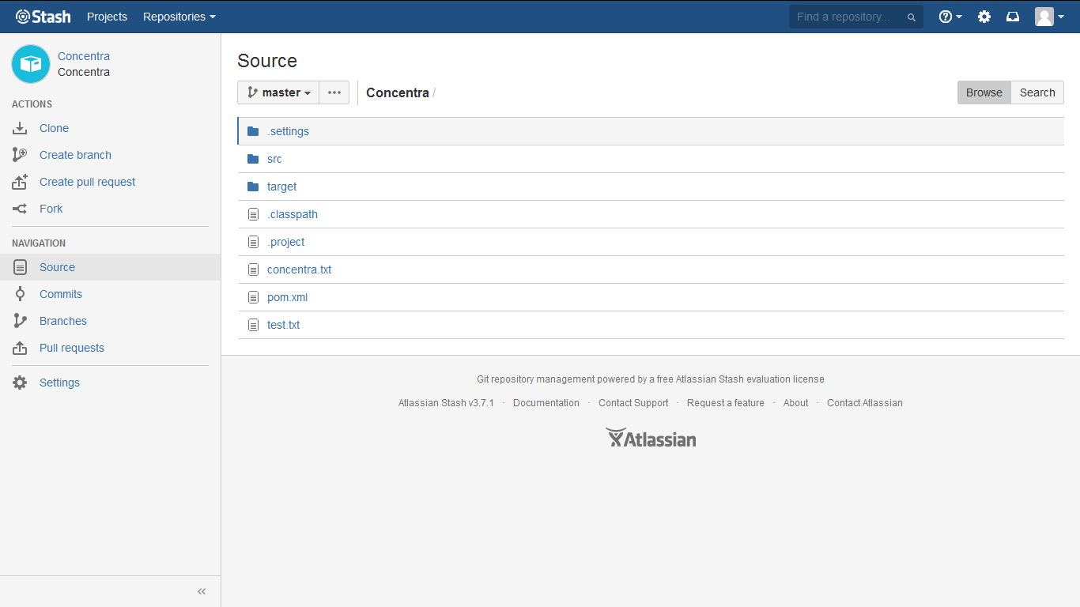

Use of TortoiseGUI
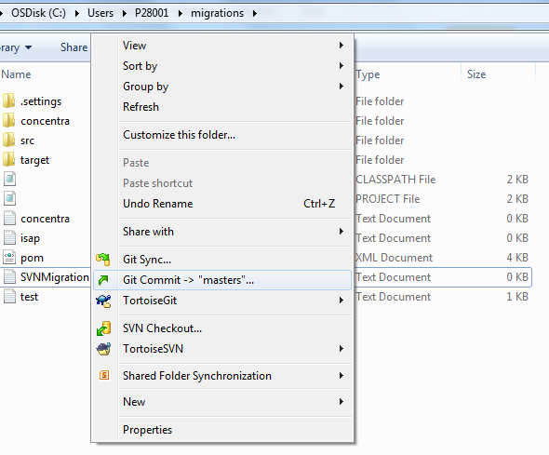

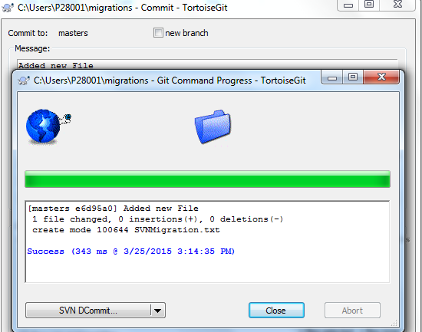

- So from this we can commit the file to our Stash server.

We need to do the following things in our Git Bash

- Login to git bash
- Mkdir folder-name
- Cd folder-name
- git remote add origin https://github.com/pradeepruban/Concentra
- git push origin https://github.com/pradeepruban/Concentra.git
- git config --global user.name "pradeep ruban"
- git clone C:\Users\P28001\demo
- add any file in the Git repository
- git add *
- git commit –m “Some message”
- git remote add origins “service URL”
- git push origin branchname

If our code already tracked by GIT, We can use the following commands
======================================================================
cd existing-project
git remote set-url origin http://pradeepruban@localhost:9000/scm/con/concentra.git
git push origin master

Following software’s I used to migrate for SVN to Stash
- Git GUI & GIT Bash(comes with git installation)
- Git Bash -> command prompt only we are creating local repository for git, and we are pushing from local repository to Stash.
- TortoiseGUI -> used to commit (add) and checkout the code.
- Stash
- TortoiseSVN(Client machine used to checkout the code from SVN Server)
- VisualSVNServer(Server is used to create repository for SVN code)

